Section 1—Ski Gear_________________________

(Above) Poles, skis, a hat, and gloves are essential for getting down the mountain and staying warm.

Cold toes, cold hands, cold ears…yuck! Nobody likes to be cold or stranded. Skiing is a sport that takes planning and preparation, both on and off the mountain. Proper clothing, ski equipment and car accessories make for a successful mountain adventure.

To stay warm on the mountain snow bunnies must be ready for anything. One of the most important elements to stay warm is a parka. A parka is a ski coat that is water and wind resistant. Keeping water and wind out helps to maintain warmth. It is also important to wear waterproof pants. Many skiers fall, and this could lead to getting wet and cold. There are a variety of pants on the market. Bibs, stirrup pants, and regular ski pants are the most common. All are water and wind proof.

It is not only necessary to have the proper outer clothes, but under clothes as well. It is best to wear wool, polypropylene, or polyester. Those materials keep out water. Cotton, although common and versatile, keeps water next to the skin. This makes people colder.

After being dressed and ready to weather the cold, skiers must have the proper equipment. Gloves, hats, and goggles keep skiers warm and help maintain focus going down the mountain. Beginning skiers can rent skis, boots and poles from their local ski shop until they are ready to make the big purchase of their own equipment. More advanced and expert skiers, most likely, will own their own equipment. Skis and bindings are the most expensive part of owning equipment, with boots coming in a close second. Ski poles are inexpensive and easy to replace.

Once fully equipped with clothes and equipment the only issues that could arise would be getting up or down the summit. Car accessories are essential parts of being prepared. Snow can be a major factor in getting to the ski resort. It is important to carry chains at all times. Just as important are extra blankets, a first aid kit, and food. If a sudden snow storm hits, drivers would have some supplies to keep them alive until help arrived. Finally, to get the ski gear to the slopes, a car needs to have a ski rack.

All in all, to have a successful time on the mountain, it is essential to have the proper clothes, equipment and car accessories. If all of those pieces are in place, success is guaranteed!

1. snow bunnies—people that enjoy looking good while playing in the snow
2. parka—a ski coat that is water and wind resistant
3. chains—cables or actual chains that give tires traction in bad weather (ice or snow)
4. ski rack—a device that attaches to the top of a car to carry skis

Section 2—Ski Techniques

Skiing is a very difficult sport to master. It takes patience, practice, and perseverance. Once deciding to take up the sport of skiing, it is important not to panic, to learn the basic skills of success, to refine the skills, and to enjoy the ride. Skiing can enable people to feel free and have a fun, joyful day on beautiful mountain slopes.
When first learning how to ski, it is important not to panic! Panicking is the first step to being unsuccessful. So, let loose…don’t worry! Have faith in the skills of the ski instructors, and yourself to achieve optimum confidence.
After the initial fear of actually skiing down a mountain, it is vital to learn the basic ski position. This position is called a snow plow. This technique helps to maintain balance as skiers careen down the hill. The first part of a snow plow is aiming the ski tips together and the backs apart. The shape of this looks similar to a piece of pie or pizza. Skiing in this position builds confidence and allows the beginning skier to gain a sense of balance.
Once mastering the snow plow, skiers are able to start learning how to straight ski and then parallel ski. Straight skiing makes a middle level skier maintain more control of their skis and turns, and it also allows skiers to have more freedom on the types of runs they want to explore.
Parallel skiing is more advanced and takes years of practice. This technique involves having both skis almost touching at the boots. The skis together form a straight line, not a pie shape like with the snow plow. To maintain balance, skiers must practice parallel skiing, as they will fall when this skill is introduced. Skiers also turn faster when using the parallel position and are able to navigate more difficult slopes.
Learning the basic techniques of skiing and practicing from year to year makes anyone a confident explorer. Practicing also enables a skier to explore various types of ski runs. Ski runs are all labeled by difficulty level. The levels are green, blue, black, and double black.

Green is the easiest followed by blue.
Black and double black are the most difficult.
(Above) The symbols above classify the various ski run levels and their difficulty.

Green runs are the easiest, with the least amount of slope. They are also, generally, the shortest. Blue squares are more difficult and longer and may include moguls. Usually a skier can navigate a blue run while using the snow plow technique.
Once mastering the basic ski techniques and practicing, an astute skier can attempt a black diamond run. This level is difficult, long and steep, and most definitely includes moguls. Black diamond slopes should only be attempted by accomplished skiers.
The final level of ski run is expert or double black. This run includes rough terrain, hazards, and should be skied in groups. The name says it all…expert only!
To get to the ski runs a skier must use a chair lift. A chair lift is easier than it looks. Skiers wait in line for their turn and move forward to the operator. Chairs pass on a cable and skiers must follow a chair to the WAIT HERE sign. This process is similar to a turn style. The chair will approach, and when the time is right, the skier sits down. Now it is time to look around at the beautiful scenery.
After a few minutes it is time to disembark. Getting off the lift is a little trickier. The lift warns the skier with signs stating “keep ski tips up.” This reminds the skier to have their feet ready to stand up. While in the air, skiing is relaxing and restful. However, getting off the lift, the skier stands at the STAND HERE sign, and pushes themselves off of the chair. The motion is similar to getting out of a dining chair.
The chair lift allows people to enjoy their time going up and down the mountain. Once on the mountain people of all ability levels can enjoy the snow, ski runs, and surroundings.

1. snow plow—a ski technique that creates balance and confidence in the beginning skier.
2. parallel—a ski technique where the skis are together in a linear position.
3. chair lift—the method of getting up the mountain to the top of the ski slope

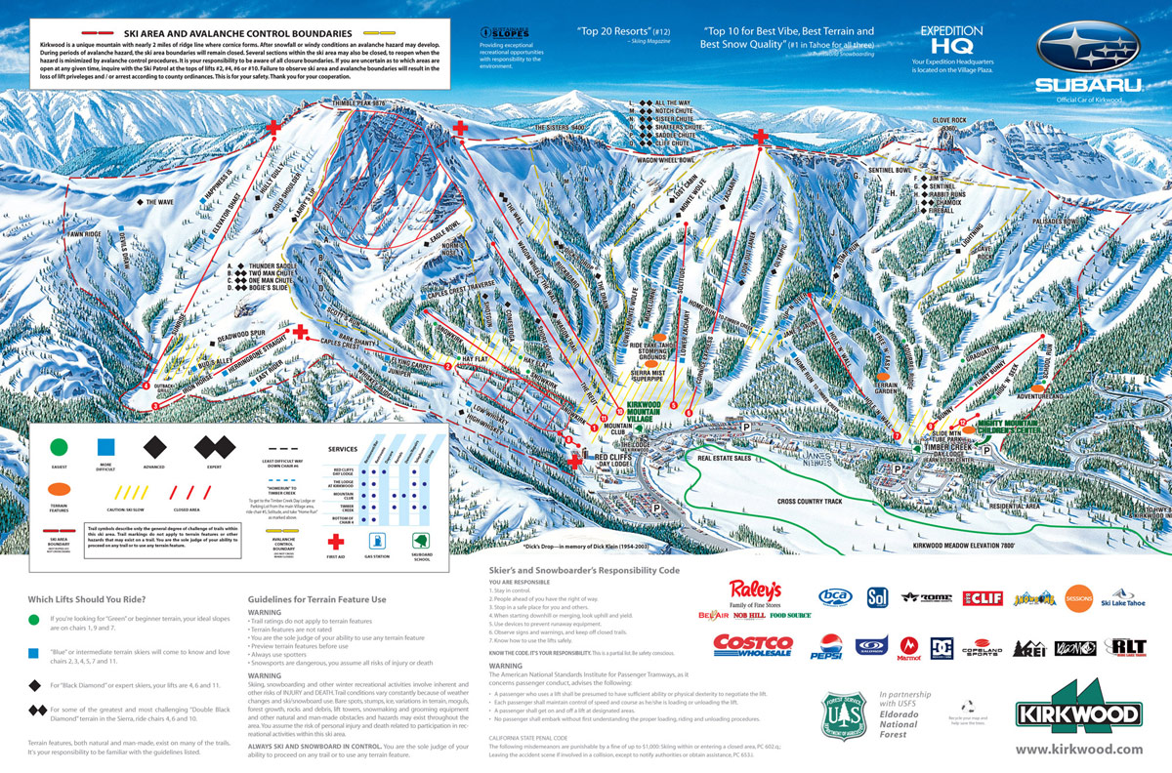

(Above) Kirkwood Ski Resort is a popular resort in Northern California. The map shows a variety of ski slopes, difficulty levels, and chair lifts.

